Overview
Balancing the needs of a growing residential community and workforce within the current Vikings game day tailgating boundary (est. 1982) with the tradition of Vikings tailgating that preceded much of this new development, the Downtown Minneapolis Neighborhood Association has worked with the Vikings to propose changes to the zone. (Under current law, Class A parking lot owners within this zone may apply for a license to host tailgating during Vikings home games.) The final decision as to the boundaries of the game day tailgating zone rests with City Council, who may elect to change the tailgating boundaries or take no action.

The DMNA has agreed that a time period of 6 hours prior to game start and 3 hours after is an appropriate window for tailgating. No other changes to the existing tailgating ordinance are proposed. Current ordinances require tailgating lot operators to provide adequate bathrooms and trash receptacles to serve tailgaters as well as remove litter within 300ft of lot boundaries. The law also prohibits amplified sound. Lot operators that fail to comply with these laws risk losing their tailgating license. The challenge for the City will be ensuring the adequate monitoring and enforcement of these regulations.

Through public meetings, letters and an electronic survey distributed by the DMNA, community members expressed strong concerns over litter and other impacts (noise, public drunkenness, public urination) that were associated with Vikings game day tailgating and festivities during the “Metrodome era”. To raise awareness and encourage improved monitoring, the DMNA will share these documented concerns with the City, Vikings, and U.S. Bank Stadium leadership as well as tailgating operators. When tailgating resumes, DMNA will gladly serve as a conduit for complaints or comments about tailgating lots from residents and/or visitors. The DMNA will track and promptly report any violations of the City’s code to Business Licensing and lot operators directly.
Proposed Changes to the 1982 Tailgating Zone
- The Downtown Minneapolis Neighborhood Association approved the revised tailgating zone within Downtown East and Downtown West as proposed by the Vikings. (Refer to Exhibit A. The proposed zone is identified by the light grey overlay.)
- Only Class A lots within the zone may apply for a tailgating license.
- This zone does not represent the DMNA’s blanket approval for tailgating street closures in this zone. The DMNA requests the opportunity to comment on proposed tailgating street closures that are not represented on this map.
- The DMNA defers to adjacent neighborhood associations for matters related to the location of tailgating outside of DMNA boundaries.

Tailgating Regulations
- Aside from revised boundaries and ensuring that tailgating does not extend beyond 6 hours prior and 3 hours after game time, the DMNA proposes no other changes to the tailgating ordinances. (Refer Exhibit B.)
- The DMNA will gladly serve as a conduit for complaints or comments about tailgating lots from residents and/or visitors. The DMNA will track and promptly report any violations of the City’s code to Businesses Licensing and lot operators directly.

Exhibit A: Proposed Tailgating Zone
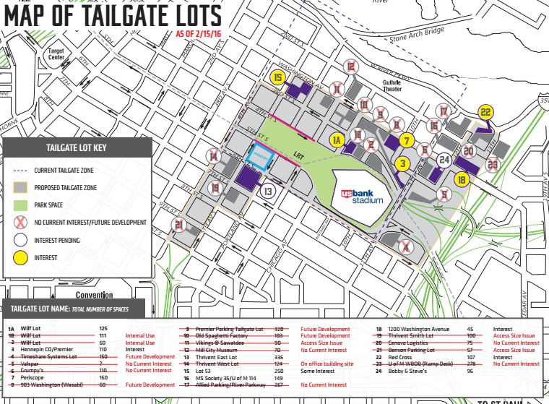
Source: Minnesota Vikings

Exhibit B: Current Tailgating Regulations
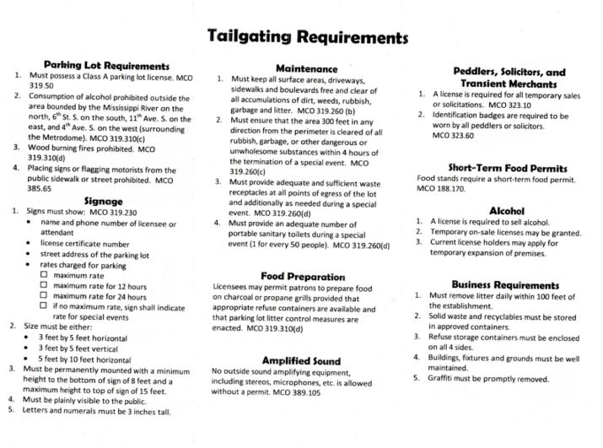
Source: Minneapolis Business Licenses Information Program

